The Honourable Shiela Malcolmson July 20, 2020
Via email sheila.malcolmson.MLA@leg.bc.ca

RE: BILL 17 AMENDMENTS
I am writing to encourage you to support Mr. Weaver’s amendments to Bill 17 or to consider scrapping it altogether. I was very surprised to hear that an NDP government would introduce such a Bill in the first place. I have been a member of the NDP for a number of years, but find this Bill does not reflect my values in the least.
The biggest risk we have to our future right now is not Covid-19, the economy nor the opioid crisis. These will all be minor compared to unmitigated climate change. By kicking the funding feet out from under various IPP projects in the province, we will neither help mitigate climate change nor move towards total independence for energy.
Further exasperating is the number of projects that were in the works for First Nations that are now no longer economically feasible. If we are to reconcile with First Nations as we have said, then allow them to build the IPP projects they have in the works with the rules/rates that they were started with. Nuu-Chah-Nulth Tribal Council President Judith Sayers said, "It seems every time the government takes a step with energy policy, it’s away from B.C. First Nations. We have the skills, capacity, desire, and the right to be partners now in creating a new energy future in B.C."
I am a retired electrical engineer and have a reasonable understanding of the ins and outs of the power grid. I support the export of energy from BC both as a resource for profit, and to strengthen the overall North American grid and reduce the need for more thermal base power production. That said, there is no reason we cannot provide a decent price for net metering for local projects and help provide for the future. We must keep in mind the total cost of energy, not just the rack rate.
If Bill 17 is passed without major amendments, I will revoke my NDP membership and monthly contribution. Please don’t make me regret helping getting you elected!
Regards,
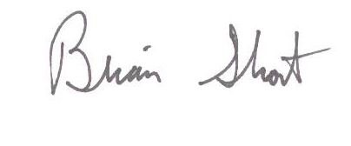
Brian Short P. Eng. (ret.)
35 Acacia Ave,
Nanaimo, BC
bkshort@shaw.ca

cc: Hon. Bruce Ralston (EMPR.Minister@gov.bc.ca)
Hon. Scott Fraser (IRR.Minister@gov.bc.ca)

