Our BC government granted Teal Cedar, a division of Teal Jones, a license to log this old forest at the head of Fairy Creek. Members of the Pacheedaht First Nation together with many environmentalists have been maintaining blockades against the logging since last summer. Pacheedaht First Nation elder Bill Jones, one of defendants named in the injunction application, says the Fairy Creek valley falls within the nation’s traditional territory and contains bathing pools with spiritual significance that are endangered by clear-cutting. Teal Cedar has requested an injunction against the blockade. B.C. Supreme Court Justice Jennifer Power has given the Fairy Creek blockade’s legal team a three-week delay to mount a defence so that the opposition to logging can have a full hearing. There are elected Pacheedaht council members supporting the logging. They have recently asked the activists to leave.

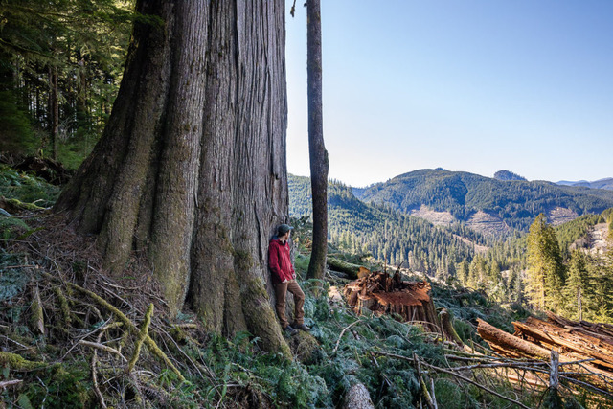
The blockade activists want to save pristine old-growth forest at the headwaters of Fairy Creek with yellow cedars thought to be 1,000 years old, as well as other remaining groves on near Camper Creek, Gordon River, and in the Upper Walbran Valley.

In September 2020, the BC Government accepted a consultants' report that recommended deferring logging in nine old -growth areas. (https://www.ancientforestalliance.org/bc-old-growth-panel-report-announcement/) This report is a good start, but does not cover all the remaining old-growth in BC. (This article in The Energy Mix leads to a map of old growth forests in BC.)

The report above refers to “a recent analysis by independent scientists. Only 2.7% of BC’s high productivity, big tree old-growth forests remain today and many of BC’s forest ecosystem types have very little old-growth remaining, leading to a high risk of permanent loss of biodiversity across much of BC. One of the panel’s recommendations to the province is to place logging deferrals in ecosystems and landscapes with very little old-growth forest remaining while a new strategy is implemented.”

A particular focal point in this struggle is the proposed logging of old-growth in the Fairy Creek watershed upstream of Port Renfrew.

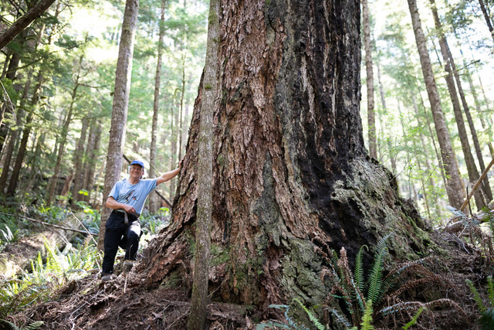
We desperately need these trees to preserve biological diversity and absorb carbon. Our seventh principle calls us to affirm and promote the interdependent web of all existence of which we are a part. This principle points to the interconnectedness of all life, and that we all depend on each other in mysterious ways for both survival and thriving. We are in the midst of a climate crisis and a mass extinction event. Old Growth forests are resistant to fires, provide resilience to the impacts of climate change, hold water, and create important habitat for a huge variety of plants, animals, and insects. To promote life thriving on this planet we must protect these forests.

